**Scorecarding Vs Trending Metrics**

In Microstrategy or other BI platforms, metrics or analytics can be broken down into two categories:

1. Scorecarding metrics and

2. Trending metrics

The distinction between the two is best illustrated with an example.

Say you're tracking sales of an item for a week. And let's say the total sales of the item for the month is $800.

Now this metric (sales) can be tracked on a daily basis which shows a trend line like:

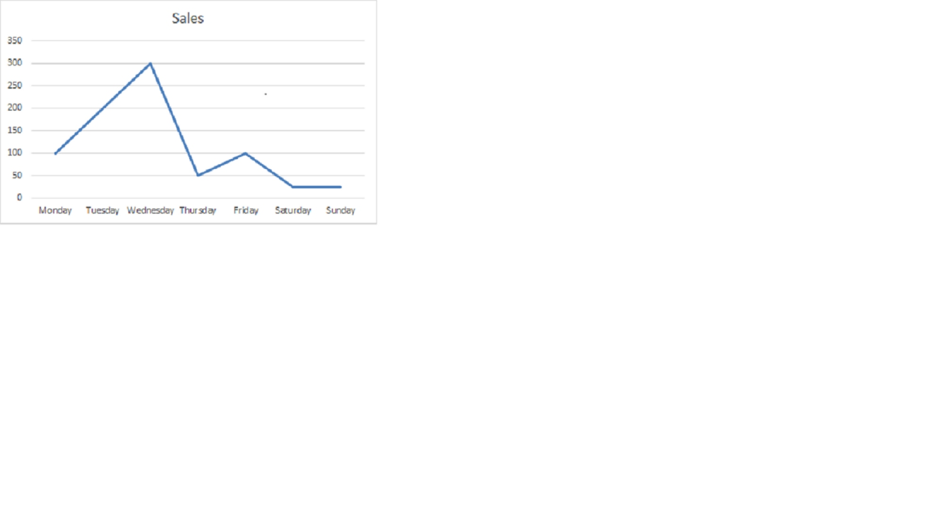

And this would be a trending metric.

Similarly we can track or view the sales as a Summary or Scorecarding metric for the week. As say sales for current week:

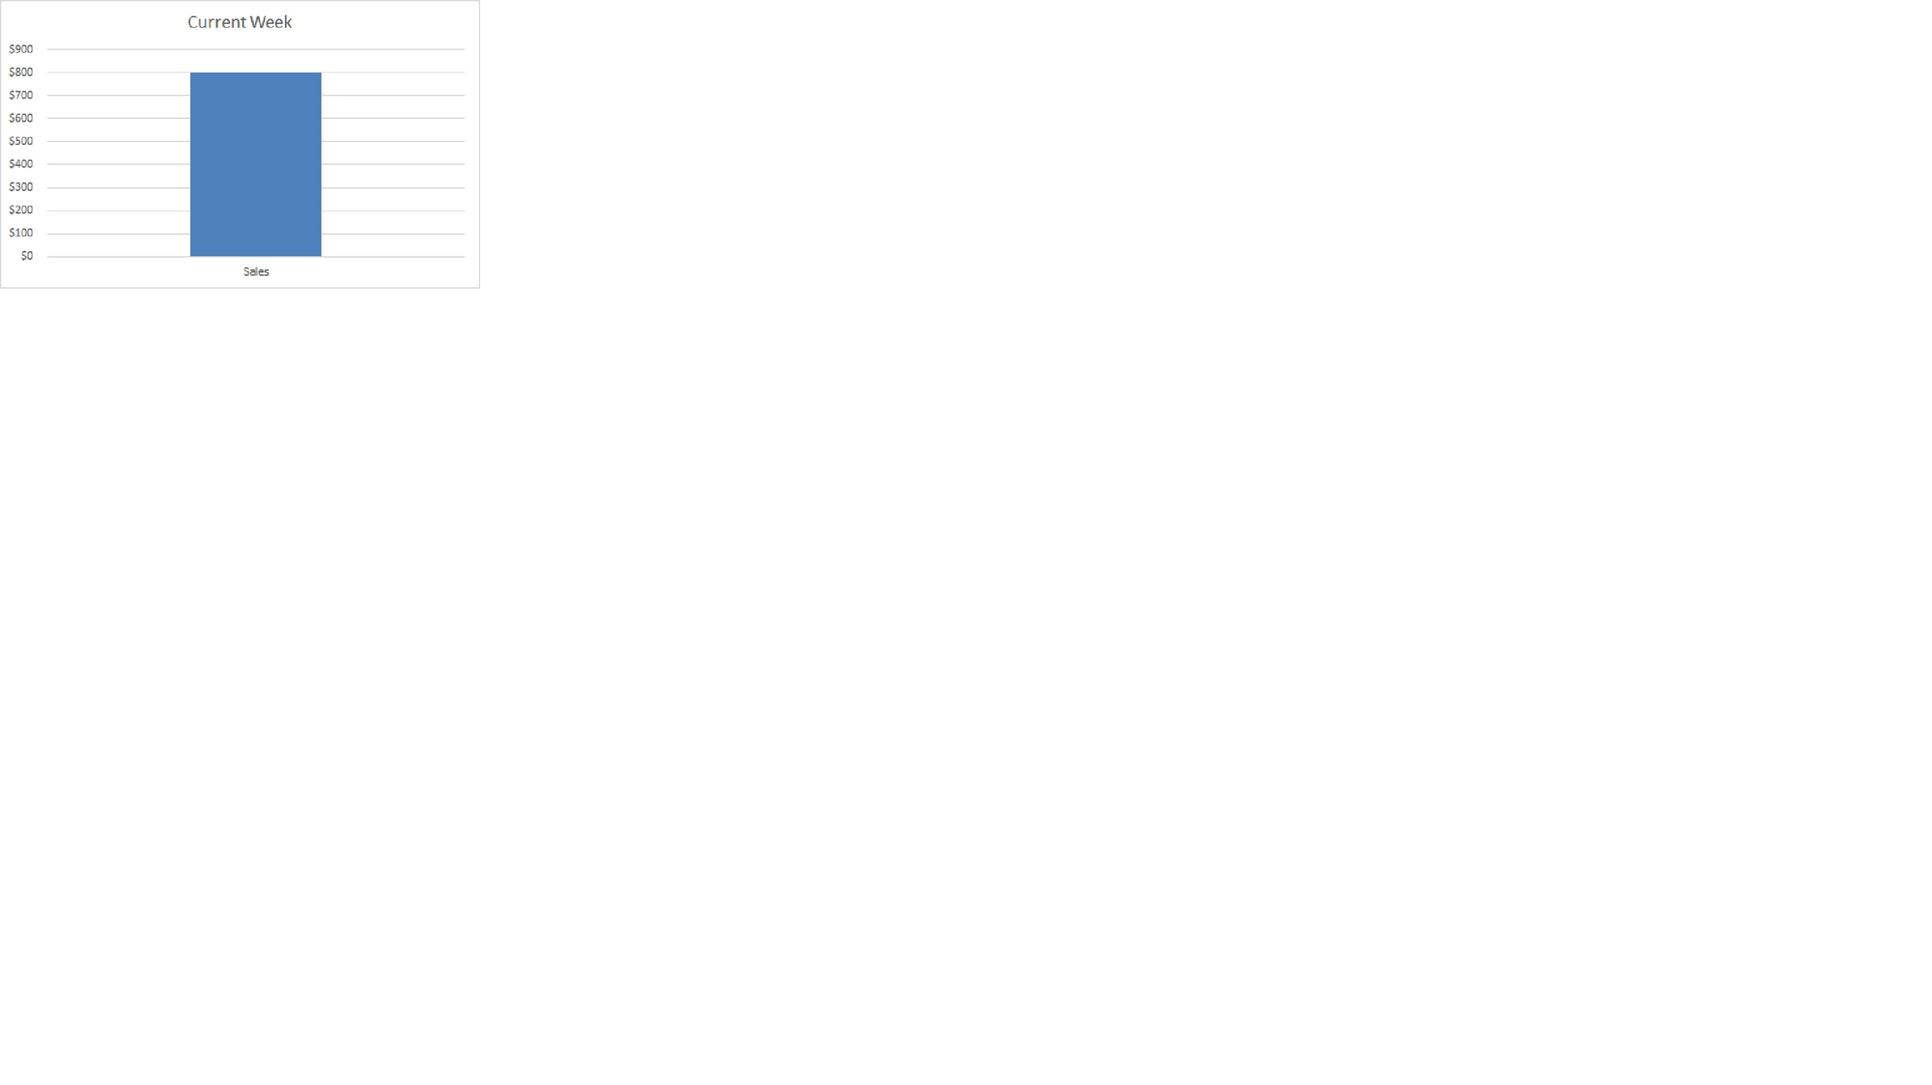

So for a metric you can have a trending version and a scorecarding version. The trending version is more granular and shows you the trends in a metrics while the Scorecarding version is more like a summary metric.

On Microstrategy or any other BI platform, you can't define metrics on the fly, all of these metrics, even the simplest ones like say daily sales, or weekly sales etc, have to be defined by a BI developer. This is because these tools don't operate on a simple column of sales values from an excel sheet.

BI tools operate on enterprise data warehouses storing millions to billions of transactions and computing metrics on these data warehouses, is a specialized job.

*— MAR 29, 2015 —*